InClass Assignment 4

**Part 1: Creating Digital Certificates**

*Step 1: Search “download openssl” on Google Chrome*

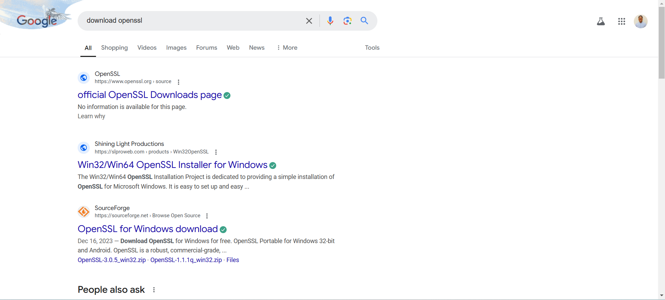

*Step 2: Go to the second link*

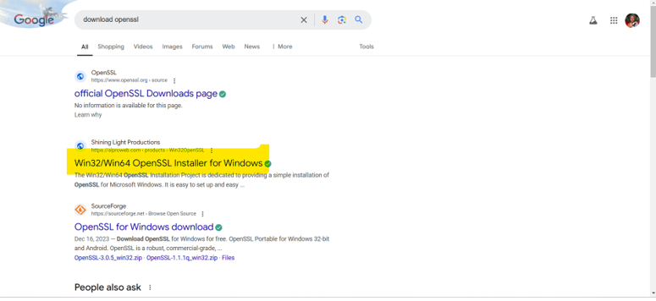

*Step 3: When in the link, look for Win64 OpenSSL v3.4.0 and download the executable*

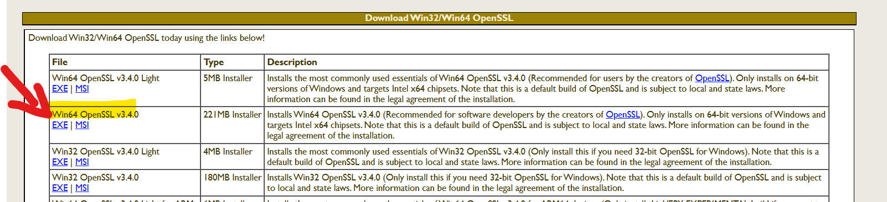

*Step 4: Download the file and wait for it*

**

*Step 5: After downloading the file, install it and do the following installation process*

**

**

**

**

**

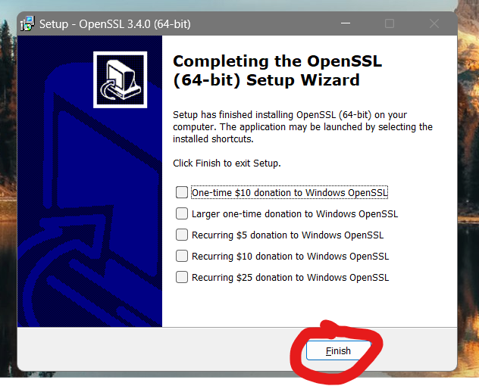

*Step 6: Once installed, do the following steps for the path of the openssl*

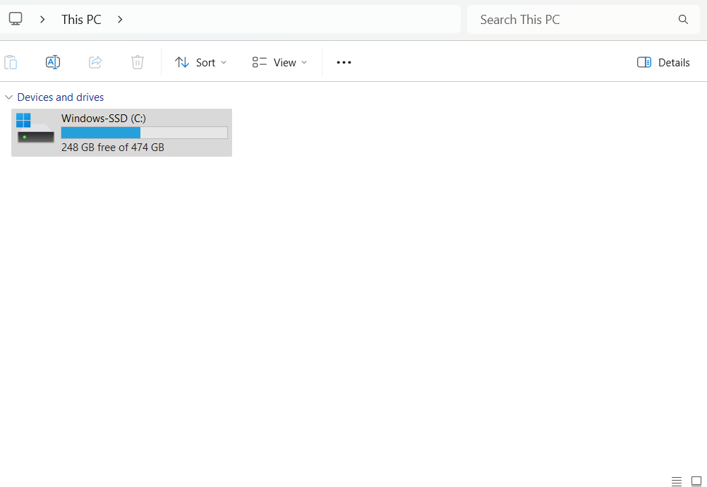

**

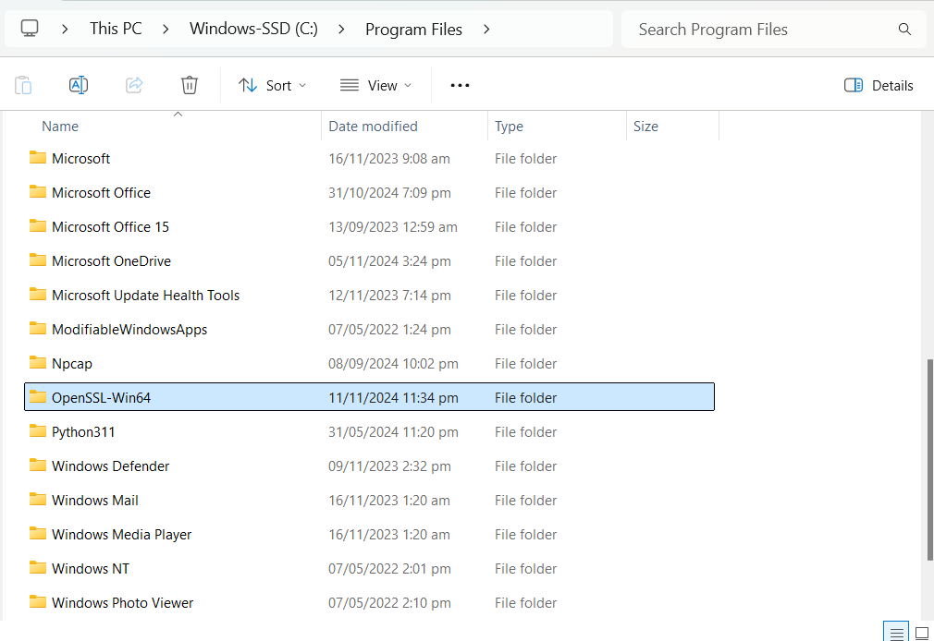

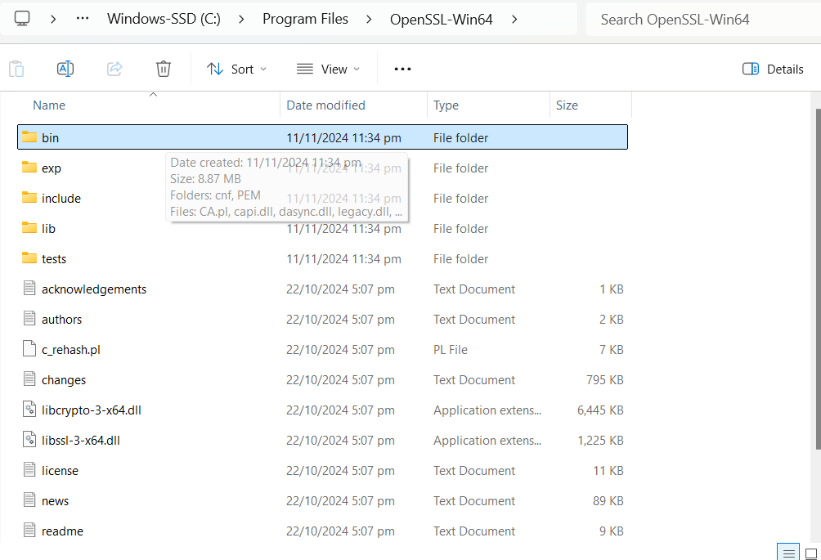

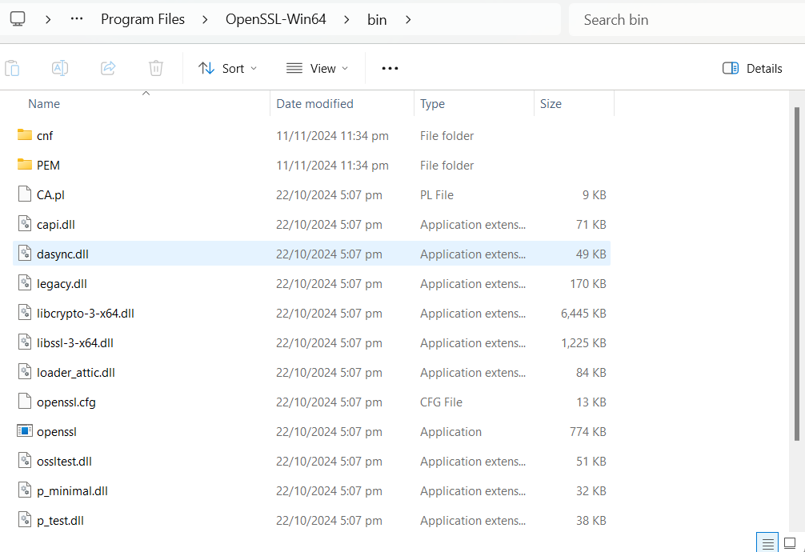

*Copy the path and do the following*

*Right click “This PC” and go to properties, and click “advance system setting”*

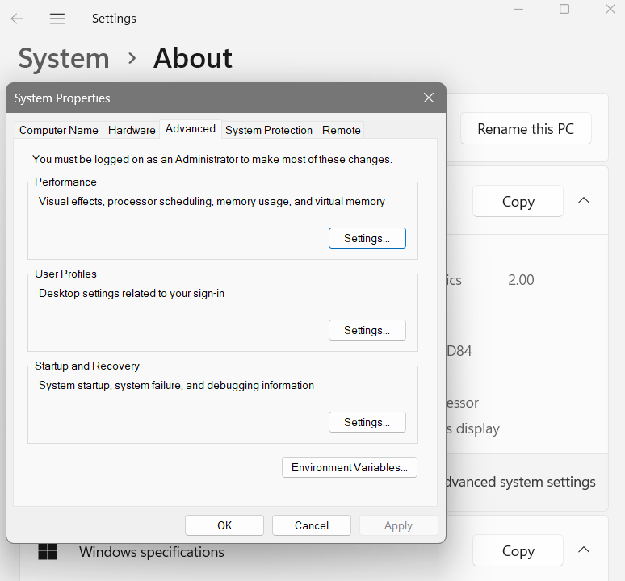

*Then, click environment variables and go to “Path” and edit*

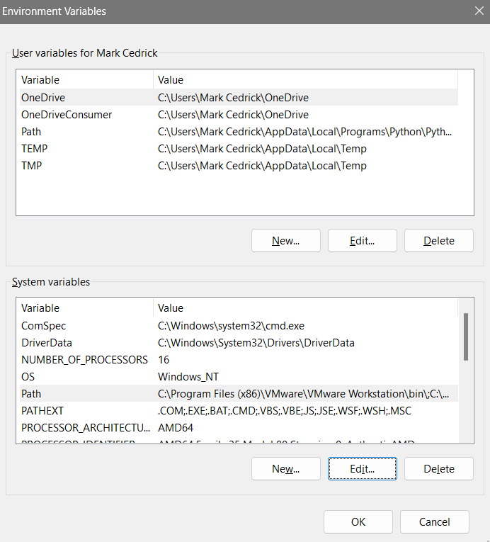

*Click New and paste the path from the openssl*

*Step 7: Open the cmd and type cd desktop to show the desktop, then type openssl to see the data*

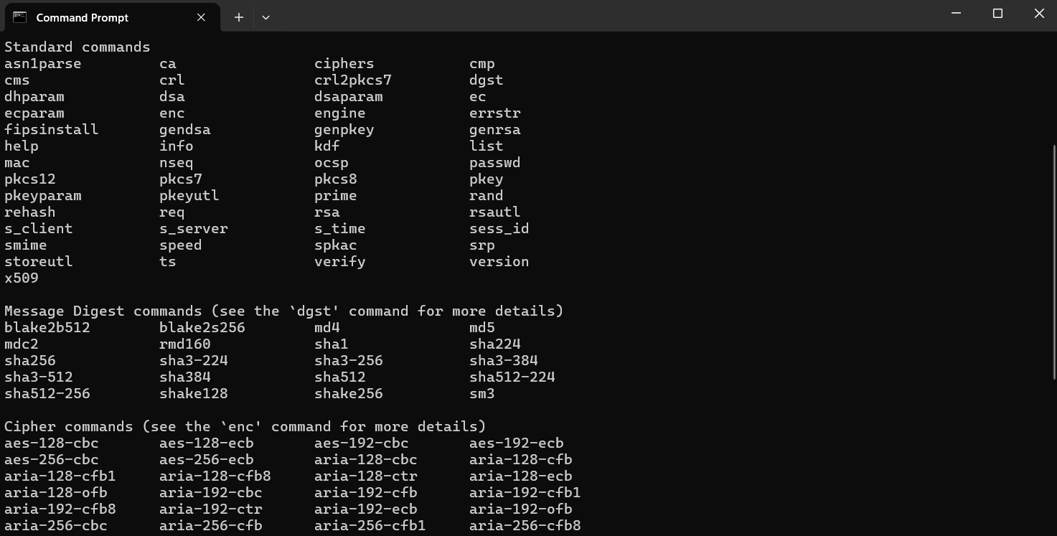

*Then, type openssl req -x509 -days 365 -newkey rsa:2048 -keyout my-key.pem -out my-cert.pem*

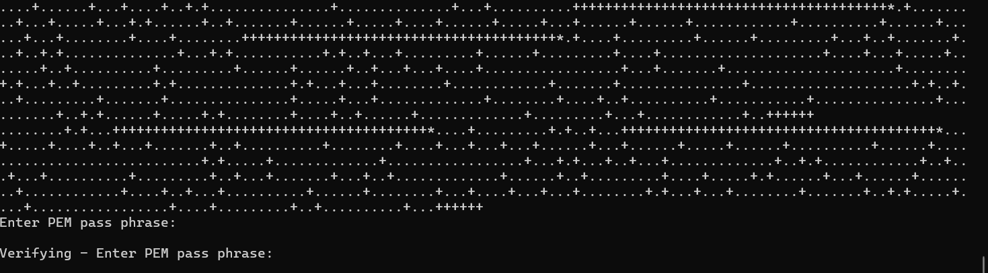

*After it has loaded, provide your own password and verify it. Then, provide the information about the country and state*

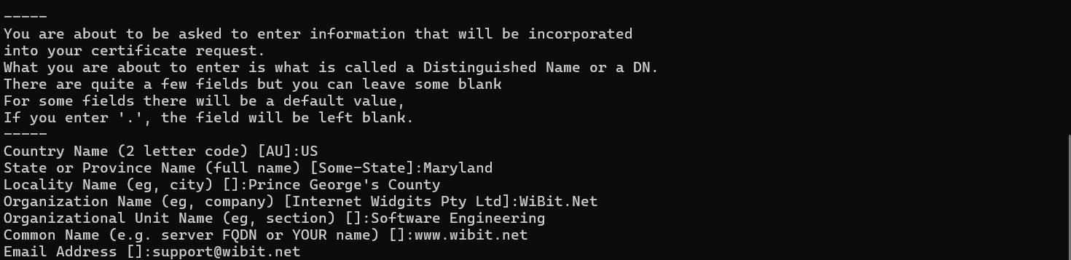

*The pem files will be added in your desktop*

**

*Step 8: Now, go back to the cmd and enter the following openssl pkcs12 -export -in my-cert.pem -inkey my-key.pem -out wibit-test-cert.pfx*

*Then, enter the password you made above*

**

*Now, another file has been added, which comprised of the two files above. You can now delete those files since you have the new combination file*

*Step 9: Exporting the public key*

*Go back to the cmd and type cls to clear the previous codes you have and then type this*

*openssl pkcs12 -in wibit-test-cert.pfx -clcerts -nokeys -out -wibit-test-cert-public.pem*

*Then, enter the import password*

**

*Then, the file has been made which can be seen in your desktop*

**

**Part 2: Using ChatGPT to write research for paper.**

Research Project

Title: **Enhancing Healthcare Monitoring Systems with Machine Learning and IoT**

Rosemarie Kpaka

Course: CTEC 402.001

Institution: Bowie State University

Semester: Fall 2024

Date: October 27, 2024

**Abstract**

The integration of Machine Learning (ML) and Internet of Things (IoT) technologies in healthcare has opened new avenues for real-time monitoring and patient care. This paper explores the application of ML algorithms to enhance IoT healthcare systems, focusing on data security and anomaly detection. Through a review of existing frameworks and methodologies, the research aims to address challenges in healthcare data protection and propose solutions for improving system resilience. Findings suggest that deploying advanced ML models, such as HealthGuard and SHChecker, can significantly bolster the security and efficiency of IoT-enabled healthcare systems.

**Introduction**

Machine Learning (ML) and the Internet of Things (IoT) are transforming the healthcare industry by providing innovative solutions for real-time monitoring and patient management. ML enables systems to learn from data patterns and make informed decisions, while IoT connects medical devices for seamless data exchange. Together, these technologies enhance patient care, improve operational efficiency, and support personalized healthcare. However, the widespread adoption of IoT devices introduces challenges related to data security and privacy, particularly in safeguarding sensitive patient information from cyber threats. This research focuses on developing secure, real-time monitoring systems using ML algorithms to address these challenges.

**Problem Statement**

As healthcare facilities increasingly rely on IoT devices for patient monitoring, concerns over data security and system vulnerabilities have grown. IoT devices, such as remote patient monitors and smart medical equipment, are prone to cyberattacks, which can compromise patient data and disrupt healthcare services. The primary objective of this research is to develop enhanced security systems using ML algorithms to detect and prevent malicious behavior in IoT healthcare networks. By leveraging ML techniques, the goal is to achieve real-time anomaly detection and ensure the protection of sensitive medical data.

**Literature Review**

The use of IoT in healthcare has expanded rapidly, enabling remote monitoring, telemedicine, and real-time patient data analysis. Various ML algorithms have been applied to enhance IoT healthcare systems, including Artificial Neural Networks (ANN), Decision Trees, and k-Nearest Neighbors (k-NN). Previous studies have shown that ML models can improve the accuracy of patient monitoring and predict potential health risks. However, ensuring data security remains a critical challenge. Recent frameworks like HealthGuard and SHChecker have been developed to detect abnormal patterns and prevent cyberattacks on IoT devices.

**Methodologies**

This research employs several ML-based frameworks to enhance IoT healthcare monitoring:

1. HealthGuard Framework:

HealthGuard uses ML algorithms such as ANN, Decision Tree, and k-NN to monitor IoT healthcare devices for abnormal activities. It analyzes data from multiple smart medical devices and compares them against predefined normal patterns to detect potential security threats.

1. SHChecker:

SHChecker is a machine learning tool designed to prevent attacks on IoT Medical Things (IoMT) systems. It employs formal analysis and ML algorithms to identify vulnerabilities and prevent data manipulation or unauthorized access.

1. Apache Spark MLlib:

The Apache Spark MLlib library is utilized for real-time intrusion detection. Supervised learning models like Random Forest and Support Vector Machines (SVM) are implemented to analyze large datasets for detecting cyber threats.

1. Azure IoT Hub:

Microsoft Azure IoT Hub provides a comprehensive platform for managing healthcare IoT solutions, enabling real-time monitoring, data analytics, and machine learning integration to enhance patient care.

**Case Studies**

In 2021, a series of ransomware attacks targeted healthcare networks, affecting devices like Voice Over Internet Protocol (VoIP) systems and IV Pumps. These attacks highlighted the vulnerabilities of IoT devices in healthcare, prompting the need for robust security measures. McAfee's Advanced Research team discovered multiple security flaws in medical IoT devices, which could be exploited to alter medication delivery and compromise patient safety. This research aims to address such vulnerabilities by integrating ML algorithms to detect and prevent cyber threats in real time.

**Data Analysis and Results**

The research evaluates the performance of different ML models in detecting anomalies in healthcare IoT data. The analysis shows that Random Forest achieved the highest accuracy (99.7%) in detecting malicious activities, followed by Decision Tree and k-NN models. The use of Apache Spark for big data processing significantly reduced the detection time, making it suitable for real-time monitoring applications.

**Discussion**

The findings demonstrate that ML algorithms can significantly enhance the security and efficiency of IoT healthcare systems. By deploying frameworks like HealthGuard and SHChecker, healthcare providers can detect and prevent cyber threats, ensuring patient data protection. The integration of cloud-based platforms, such as Azure IoT, further supports scalability and real-time data analysis, making it a viable solution for modern healthcare challenges.

**Conclusion**

In conclusion, the integration of ML and IoT technologies in healthcare offers numerous benefits, including improved patient monitoring, data security, and operational efficiency. However, the increasing use of IoT devices also presents security challenges that need to be addressed. This research highlights the potential of ML algorithms in enhancing the security of IoT healthcare systems, recommending the adoption of advanced frameworks for real-time monitoring and threat detection. Future research should focus on developing more robust ML models and exploring their applications in different healthcare settings.

**References**

1. Tallapaneni, N., & Venkatesan, M. (2021). IoT-based smart healthcare system monitoring using machine learning. IEEE Xplore.
2. Segarra, J. (2022). Malware attacks targeting healthcare IoT devices. Soracom Blog.
3. Sundas, A. et al. (2022). HealthGuard: Intelligent healthcare system security framework. MDPI.
4. Haque, N., Rahman, M. (2021). Threat analysis of machine learning-based healthcare systems. Arxiv.
5. Morfino, V., Rampone, S. (2020). Real-time intrusion detection using Apache Spark. MDPI.

**PPT Content Slide**

**Slide 1: Title Slide**

**Title:** Enhancing Healthcare Monitoring Systems with Machine Learning and IoT  
**Presented by:** Rosemarie Kpaka  
**Course:** CTEC 402.001  
**Date:** October 27, 2024

**Slide 2: Introduction**

* Machine Learning (ML) and Internet of Things (IoT) are revolutionizing healthcare.
* Focus on real-time patient monitoring and data security.
* Research objective: Enhance IoT healthcare systems using ML algorithms.

**Slide 3: Problem Statement**

* IoT healthcare devices face security challenges.
* Need for real-time monitoring to detect anomalies.
* Aim: Develop ML-based solutions for data protection.

**Slide 4: Methodologies Overview**

* HealthGuard: Monitors smart medical devices using ML.
* SHChecker: Detects cyber threats in IoT healthcare.
* Apache Spark: Real-time data analysis for threat detection.
* Azure IoT Hub: Enhances healthcare monitoring.

**Slide 5: HealthGuard Framework**

* Uses ML algorithms (ANN, k-NN) to detect abnormal patterns.
* Achieves 91% accuracy in identifying security threats.

**Slide 6: SHChecker Framework**

* ML tool for preventing attacks on IoMT devices.
* Formal analysis to secure healthcare data.

**Slide 7: Case Studies**

* 2021 ransomware attacks on healthcare IoT devices.
* McAfee findings: Vulnerabilities in IV Pumps and VoIP systems.
* Emphasis on ML solutions for enhancing security.

**Slide 8: Data Analysis**

* Random Forest achieved 99.7% accuracy in detecting threats.
* Apache Spark reduced detection time, supporting real-time monitoring.

**Slide 9: Discussion & Insights**

* ML enhances the security of IoT healthcare systems.
* Adoption of frameworks like HealthGuard ensures patient data protection.
* Integration with cloud platforms supports scalability.

**Slide 10: Conclusion**

* ML and IoT integration improves healthcare efficiency.
* Focus on real-time monitoring and data security.
* Recommendations: Adopt advanced ML models for future healthcare solutions.

**Slide 11: Q&A**

* Thank you!
* Any questions?